

Enjoy the comfort and convenience of modern townhome living at Meadows of Keefer Creek. Our spacious two-story apartment townhomes are designed to make everyday life easy, with private entrances, attached garages, and thoughtfully designed interiors in a beautifully maintained north Fort Wayne community close to shopping, dining, and Carroll District Schools.
Community & Home Amenities

- Attached garage with private entrance
- Master bedroom walk-in closet
- Kitchen island with extra storage
- In-unit washer and dryer
- Private patio
- High-speed internet access
- 24-hour emergency maintenance
- Convenient north Fort Wayne location
- Carroll District Schools
Hickory Center Elementary

Carroll MS & Carroll HS
Monthly Rates
- 3 Bedroom/2.5 Bath Unfurnished……………..………………………………....$1,995/month + Prorated water charge
- 3 Bedroom/2.5 Bath Furnished, all utilities included-……………….……..$2,500/month
Deposits & Fees
- Application Fee (Apply at www.keefercreek.com)……........................$40 per person
- Move-In Deposit……………………………Unfurnished-$1,995/Furnished-$2,500/month
- Non-Refundable Pet Fee (one time/max of 2 pets)30 lb limit…………...$300 per pet
No monthly pet fee
Units are all electric & the responsibility of the resident. Please call IN Mich Power for cost estimates: 800-311-4634

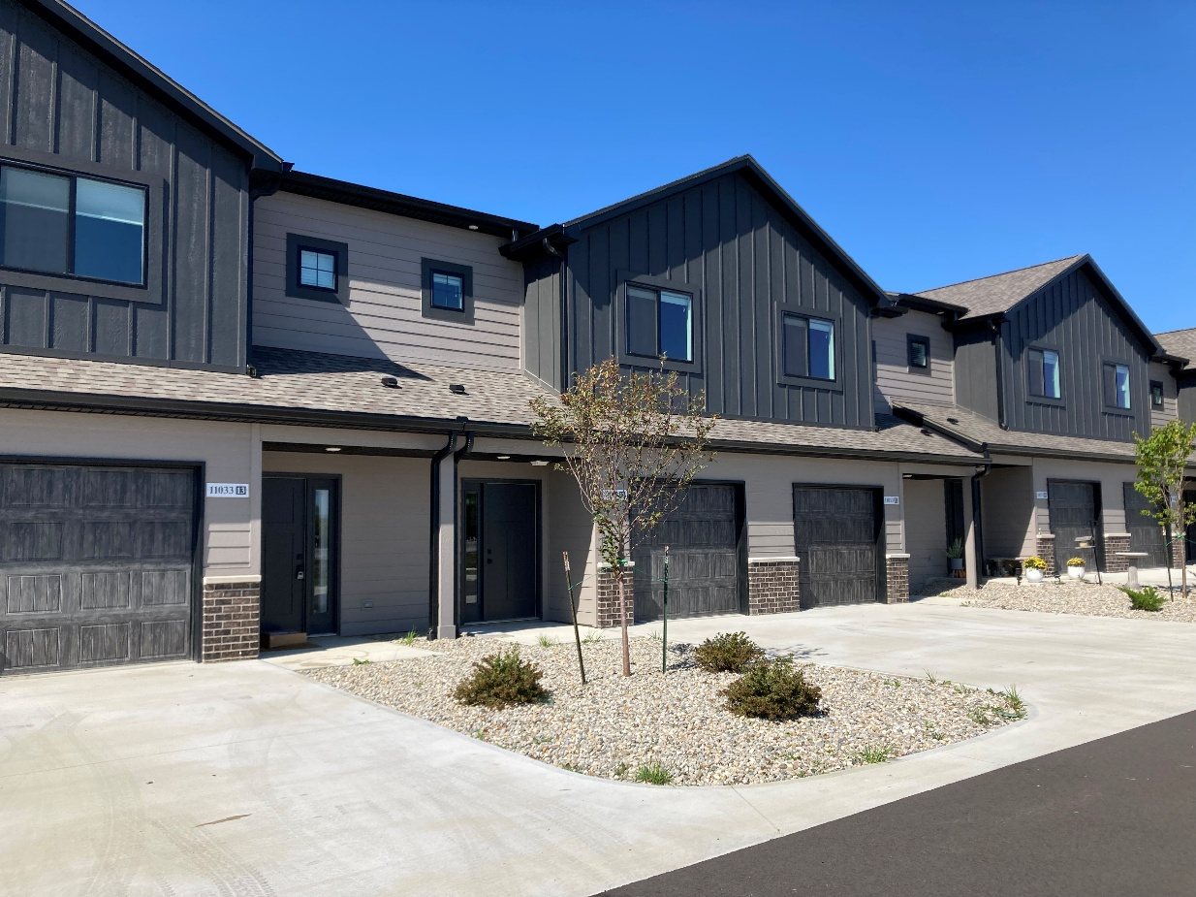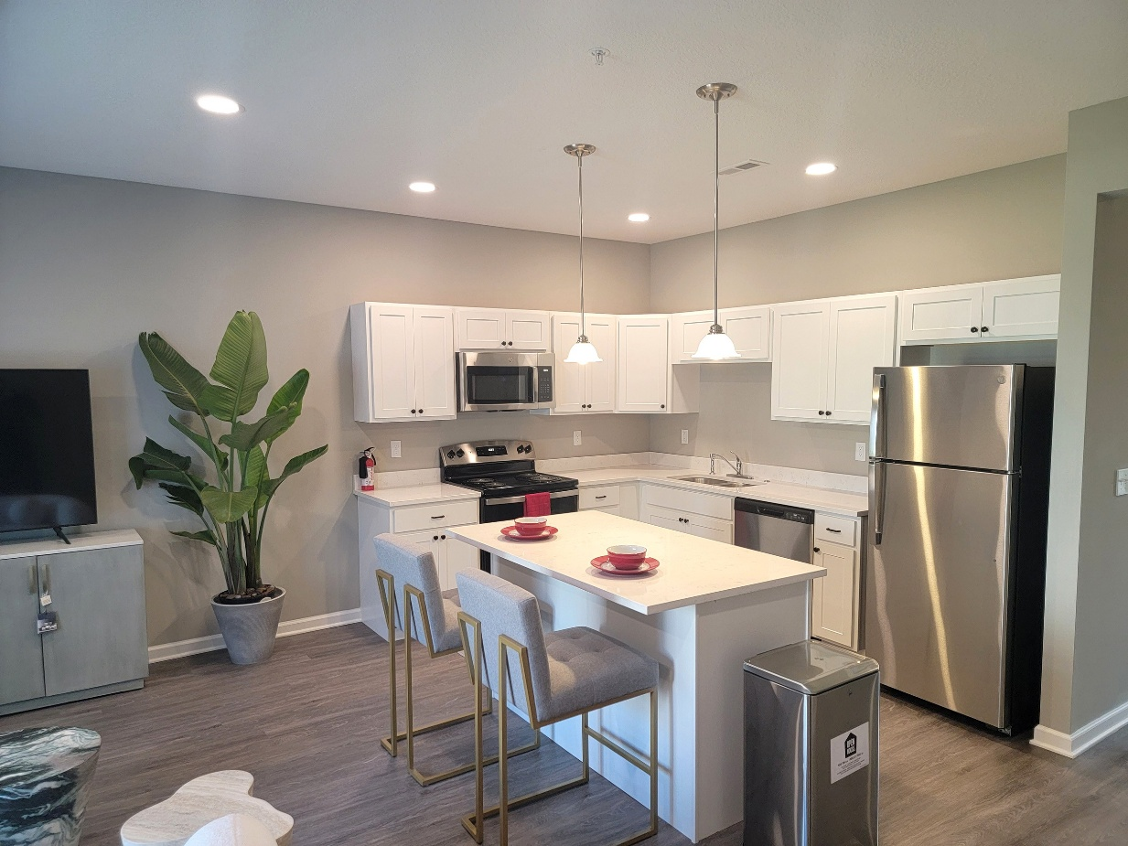
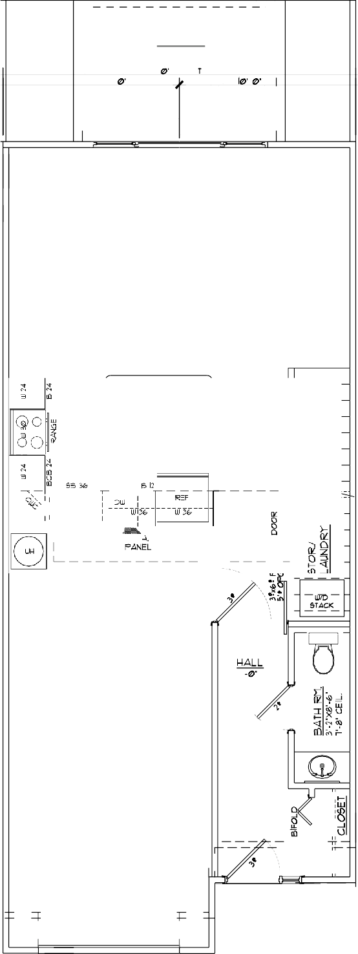
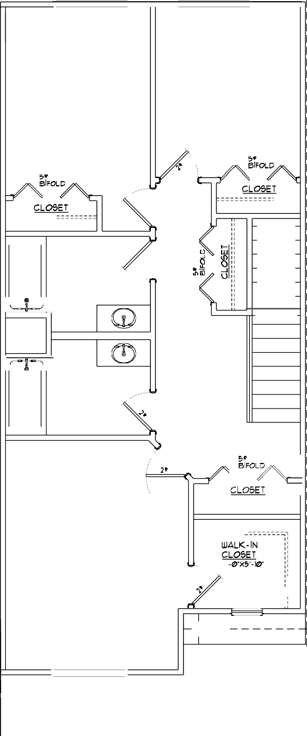
First Floor Second Floor
BEDROOM
9'-b'Xl2'-4'
BEDROOM
9'-i&'X\l'-2'
.,,
�
f.lALL
BATf.l RM.
9'-b'Xb'-3'
MASTER BEDROOM l2'-0'Xl5'-0' 9'-0' CEIL.
1'
8'-IZI' CEIL.
+--
I
I
� I
- �
I I I I
ol
I
I
- �

